

**המחלקה להנדסת חשמל**

**Project Name:**

**Noise Reduction from an Acoustic Signature of a Total Hip Arthroplasty**

Students name: Tamir Shoresh & Dan Goren

Lecturer name: Dr. Hadas Lapid

Submission date: 06.09.22

Abstract:

This study proposes a novel denoising technique, aimed to maximize the sound-to-noise ratio (SNR) of total hip arthroplasty (THA) acoustic recordings, using digital signal processing (DSP) tools to map the characteristic frequency distribution of background noise in the operating room (OR). The current tactic used by orthopedic surgeons to determine the optimal endpoint of implant and broach insertions in THAs is by listening to acoustic cues, the subjective nature of which may cause imperfections, risking an improper primary implant fixation. The audio recordings used in this study were acquired in an experimental setup including 31 live patients undergoing THA. The recordings were processed by means of a DSP pipeline containing a DC offset differentiator, Normalization Block, Hanning smoothing and segmentation block, and a spectral over-subtraction filter. We evaluate the proposed architecture by comparing the loss of energy in hammer-on-broach segments versus noise segments before and after the final filter. The proposed architecture was able to separate hammer-on-broach hit sounds from background noise of the OR and filter out 89.659% of the noise while only losing 8.651% of signal energy.

This solution demonstrates promising results for THA acoustic signal filtration, whilst mapping out the characteristic frequency distribution of OR noise in the range of 0-100 [kHz]. This method has the ability to emphasize the sounds of hammer-on-broach hits, which in the ears of an experienced surgeon, can make a vast difference in the selection of the optimal endpoint. Furthermore, the proposed method contributes to the transition from subjective-based to automated, frequency-based, endpoint selection, which has the potential to be more accurate and reliable than a surgeon’s decision, towards surgical use.

1. Introduction:

Cementless fixation has become an increasingly popular method of fixation in total hip arthroplasty (THA) surgeries (Lübbeke et al., 2018). This operation includes fitting an implant, also referred to as a “femoral stem”, into a femoral cavity, carved using hand-held reamers and broaches by means of hammer blow. Immediate postoperative stability of the femoral stems is an important factor for long-term success of the THA (Gheduzzi & Miles, 2007), therefore finding the optimal endpoint of the implant is the key to a successful operation (Jasty et al., 1997). Orthopedic surgeons use different tactics to determine the optimal endpoint of implant insertion, such as visual and acoustic cues, however these tactics are based off the personal experience of each surgeon. The subjective nature of these decisions may lead to slight differences in outcomes of the operation, risking an improper primary implant fixation (Goossens et al., 2021). An implant fixation may be considered as improper when it is either insufficiently fit, which may lead to early loosening of the implant (Brien et al., 1992), or excessively press-fit, which may cause intra-operative fractures to the bone (Lindahl, 2007; Tsiridis et al., 2003). In order to overcome the problems associated with subjective endpoint selection, multiple studies have been carried out investigating the acoustic emission of intra-operative hammer-on-broach and hammer-on-implant contact (Abdulkarim et al., 2013; Morohashi et al., 2017; Oberst et al., 2018; Paech et al., 2008; Sakai et al., 2011; Unger et al., 2009). For example, Whitwell et al., 2013, characterized the pitch changes produced by the femoral broaches and the definitive implant by analyzing the sound spectra created by the first broach, last broach and implant using spectral analysis software.

When processing THA acoustic emission recordings, one must consider the excessive noise of the modern operating room (OR). Studies have shown that ORs are among the most problematic areas in the healthcare industry, with peak noise levels that can reach up to 100‐120 dB (West et al., 2008). In the study of Kracht et al., 2007, sound pressure levels of the ORs in Johns Hopkins Hospital were monitored before, during, and after operations, mapping out the frequency distribution of noise, in the range of 0-20 [kHz], for 11 different types of operations.

The paper of Upadhyay & Karmakar, 2015, suggests a denoising technique that includes estimating the noise spectrum during pauses between definitive signals and using a spectral subtraction algorithm to remove that sound spectrum from that of the signal.

This study proposes using a spectral over-subtraction filter on the THA acoustic emission recordings, aimed to maximize the post-filter energy of the hammer-on-broach signal while minimizing the post-filter energy of the noise. In the process, a mapping of the spectral distribution of noise in the OR in the range of 0-100 [kHz] has been carried out.

1. Methodology:

The goal of this study is to filter out as much noise from acoustic recordings. In order to do so, several steps must be implemented. As shown in Figure 1, the input recordings must undergo a DC offset differentiator and an amplitude normalization before using a smoothing function to detect the energy peaks representing the hits of hammer-on-broach. Using these peaks, the recordings will be segmented into signal segments, which are the desired hit segments, and noise segments, taken from pauses in the recording. Following this procedure, both the signal and noise segments will be transferred to the frequency domain where a spectral over-subtraction filter will subtract the spectral distribution of the noise from the spectral distribution of the signal, resulting with a cleaner signal with a higher SNR.

This section will delve deeper into each block of the proposed Digital Signal Processing (DSP) pipeline.

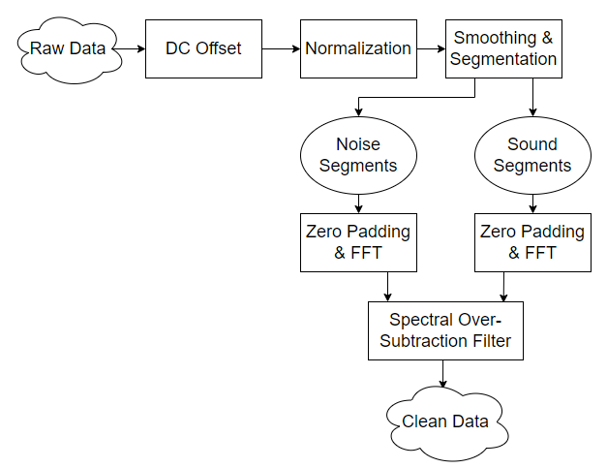

Figure - The proposed DSP pipeline that every recording will undergo

DC offset

Different types of audio cards may add varying DC (Direct Current) components to the recorded audio signal, as depicted in Figure 2. These DC components may negatively influence the computation of the digital signal processing (DSP) approaches implemented in this work (Partila et al., 2012).

Figure - Example of signal with DC offset

The DC component of the input signal can be computed as a mean value of all samples as expressed in Eq. (1):

$$\left(1\right) μ_{s}= \frac{1}{N}\sum_{i=1}^{N}{s\left(n\right)}$$

With $μ_{s}$ being the mean value of samples, $N$ being the number of samples and $s(n)$ being the input signal.

The DC component can then be removed by a simple subtraction of mean value as expressed in Eq. (2):

$$\left(2\right) s`\left(n\right)= s\left(n\right)-μ_{s}$$

With $s`\left(n\right)$ being the signal after removal of the DC component.

Normalization

After the DC offset reduction, the signals must all be normalized to a peak absolute value of 1 in respect to their own extrema values. This is done to maintain uniformity between all recordings.

Smoothing and Segmentation

As seen in Figure 3, the recordings are constructed of neighboring hits, separated by background noise intervals of varying lengths. The process of separating hits from noise includes smoothing each recording using a Hanning filter with a length of 500 samples (~2.604 milliseconds) followed by a peak search algorithm dedicated to finding the extrema point of each hit. The boundaries of each hit segment were defined by the points of 99.99% decay, with respect to each local peak, from both its sides. Because the decay rate when searching backward was much steeper than when searching forward, it was decided to lengthen the end of the segment to be the maximum between said decay point and a 140-millisecond interval. Deliberate action was taken to prevent overlap between windows. The remaining intervals were considered as background noise, although the later calculation of the average noise spectrum made use only of noise interval longer than 320 milliseconds to assure that no actual hit sound leaked into these segments. These noise segments were cut into smaller intervals of 120-160 milliseconds to keep the average size of a noise segment as close as possible to the average size of a signal segment.

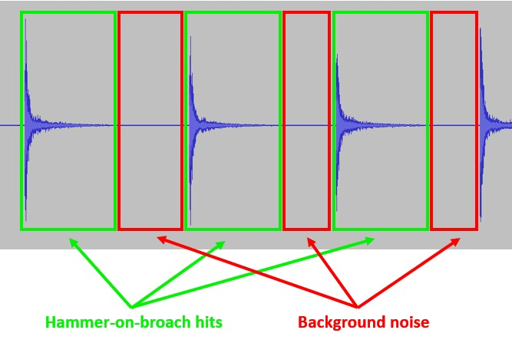

Figure - Example of an audio recording in the time domain divided into signal and noise segments. Green squares represent the part of the signal containing the hits. Red squares represent the part containing noise.

Zero Padding and Fast Fourier Transform

The now-separated sound and noise intervals must be transitioned to the frequency domain by means of a Fast Fourier Transform (FFT). A problem arises facing the fact that the sound and noise intervals vary in length. To maintain a constant resolution of 1[Hz] in the frequency domain, each segmented signal will be padded with zeros such that it’s length will be 200,000 samples. This technique is implemented by simply adding zeros at the end of each segmented signal, thus preserving the spectral behavior of the signals.

After zero padding both signal and noise segments separately, the segments undergo an FFT and are passed to the spectral over-subtraction filter.

Spectral Over-Subtraction Filter

Consider a noisy signal which consists of a wanted signal, in this case hit sounds, degraded by statistically independent additive noise as shown in Eq. (3):

$$\left(3\right) y\left(n\right)=s\left(n\right)+d(n)$$

Where y(n), s(n) and d(n) are the sampled noisy recordings, clean signal, and additive noise, respectively. It is assumed that additive noise is zero mean and uncorrelated with the clean signal. Because the signal is non-stationary and time variant, the noisy recording is often processed on a frame-by-frame basis. Their representation in the frequency domain is given by Eq. (4):

$$\left(4\right) Y\left(ω,k\right)=S\left(ω,k\right)+D\left(ω,k\right)$$

Where k is a frame number. Since the raw recordings have already been segmented into frames, we drop k for simplicity. Since the signal is assumed to be uncorrelated with the background noise, the power spectrum of y(n) has no cross-terms. Hence, the signal can be estimated by subtracting a noise estimate from the raw recording, as shown in Eq. (5):

$$\left(5\right) {\left|S(ω)\right|}^{2}= {\left|Y(ω)\right|}^{2}- {\left|D(ω)\right|}^{2}$$

The estimation of the noise spectrum ${\left|D(ω)\right|}^{2}$ is obtained by averaging the spectral behavior of the noise segments categorized in earlier stages:

$${\left(6\right) \left|D(ω)\right|}^{2}= \frac{1}{M}\sum_{j=0}^{M-1}{{\left|N_{j}(ω)\right|}^{2}}$$

Where M is the number of noise segments and $N_{j}$ are the segments themselves (Upadhyay & Karmakar, 2015).

Spectral subtractive-type algorithms are the family of different variants of the spectral subtraction method shown above. The variant chosen for the task of filtering the acoustic recordings is the spectral over-subtraction filter. In this algorithm (Berouti et al., 1979), two additional parameters are introduced in the spectral subtraction method (Boll, 1979): over-subtraction factor, denoted as α, and noise spectral floor to reduce the remnant noise, denoted as β. The algorithm is given as:

$$\left(7\right) {\left|\hat{S}(ω)\right|}^{2}= \left\{\begin{aligned}{\left|Y(ω)\right|}^{2}- {α\left|D\left(ω\right)\right|}^{2} ; if{ \left|Y\left(ω\right)\right|}^{2}>(α+β){\left|\hat{D}\left(ω\right)\right|}^{2} \\ β{\left|D\left(ω\right)\right|}^{2} ; else \end{aligned}\right.$$

With $α≥1$ and $0≤β≪1$. The over-subtraction factor controls the amount of noise power spectrum subtracted from the noisy signal power spectrum in each frame and spectral floor parameter prevent the resultant spectrum from going below a preset minimum level rather than setting to zero. Note that this filter affects only the power spectrum and not the phase of the Fourier transform.

1. Results:

Using the proposed DSP pipeline, the input 275 recordings were divided into 5643 signal segments and 3580 noise segments. The average length of a signal segment is 157.2873 milliseconds, adding up to a sum of 887.5722 seconds of signal data. The average noise length of a noise segment is 157.5809 milliseconds, adding up to a sum of 564.1396 seconds of noise data.

Using the noise segments, the average spectrum distribution of the OR background noise was mapped as visible in Figure 4.

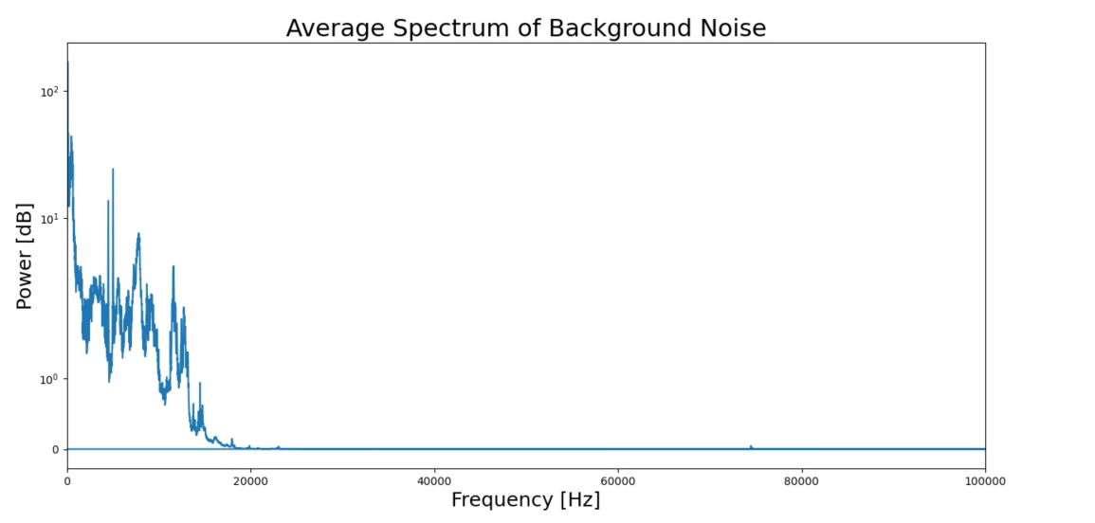

Figure - Average spectral distribution of background noise in the operating room

With this spectral distribution at hand, the next step is to optimize the parameters of the spectral over-subtraction filter, α and β, to the given signal segments. The results were evaluated using 2 key performance indicators (KPI):

1. The average percentage of energy remaining in the desired signal after filtration, with respect to that signal energy before filtration.
2. The average percentage of energy remaining in the noise segments after filtration, with respect to that noise segment’s energy before filtration.

The results of the optimization can be seen in Table 1:

|  |  |  |  |  |
| --- | --- | --- | --- | --- |
| α | β | KPI 1 (%) | KPI 2 (%) | Difference |
| 1 | **0** | 98.750 | 33.892 | 64.858 |
| 2 | **0** | 97.733 | 25.528 | 72.205 |
| 3 | **0** | 96.801 | 20.784 | 76.017 |
| 4 | **0** | 95.925 | 17.892 | 78.033 |
| 5 | **0** | 95.090 | 15.832 | 79.258 |
| 6 | **0** | 94.290 | 14.259 | 80.031 |
| 7 | **0** | 93.519 | 13.005 | 80.514 |
| 8 | **0** | 92.773 | 11.969 | 80.804 |
| 9 | **0** | 92.051 | 11.095 | 80.956 |
| 10 | **0** | 91.349 | 10.341 | 81.008 |
| 11 | **0** | 90.666 | 9.682 | 80.984 |
| 12 | **0** | 90.000 | 9.103 | 80.897 |
| 13 | **0** | 89.352 | 8.587 | 80.765 |
| 14 | **0** | 88.718 | 8.127 | 80.591 |
| 15 | **0** | 88.100 | 7.713 | 80.387 |
| 1 | **0.0005** | 98.751 | 34.531 | 64.220 |
| 2 | **0.0005** | 97.734 | 25.924 | 71.810 |
| 3 | **0.0005** | 96.802 | 21.428 | 75.374 |
| 4 | **0.0005** | 95.926 | 18.537 | 77.389 |
| 5 | **0.0005** | 95.091 | 16.477 | 78.614 |
| 6 | **0.0005** | 94.291 | 14.904 | 79.387 |
| 7 | **0.0005** | 93.520 | 13.650 | 79.870 |
| 8 | **0.0005** | 92.774 | 12.614 | 80.160 |
| 9 | **0.0005** | 92.051 | 11.741 | 80.310 |
| 10 | **0.0005** | 91.349 | 10.986 | 80.363 |
| 11 | **0.0005** | 90.666 | 10.328 | 80.338 |
| 12 | **0.0005** | 90.001 | 9.748 | 80.253 |
| 13 | **0.0005** | 89.352 | 9.233 | 80.119 |
| 14 | **0.0005** | 88.719 | 8.773 | 79.946 |
| 15 | **0.0005** | 88.100 | 8.358 | 79.742 |

Table - Results of spectral over-subtraction filter parameter optimization

On the far-right side of Table 1 the difference between the remaining signal energy and the remaining noise energy were calculated for every value of α and β.

As can be seen in Figure 5, the difference between the two KPIs grows until reaching a maximum at a value of $α=10$. In addition, throughout the entirety of the optimization, a value of $β=0$ showed slightly better results than that of $β=0.0005$. Therefore, the final value of β was chosen to be 0.

The distribution of remaining signal and noise energy after filtration using the optimal values of α and β can be seen in Figure 6 and Figure 7 respectively.

Figure - Difference between the remaining energy of the signal (KPI 1) and the remaining energy of the noise (KPI 2). The red dots represent the maximum point of each curve.

Figure - distribution of remaining signal energy after filtration among all signal segments. The mean value is 0.9135. The standard deviation is 0.06236

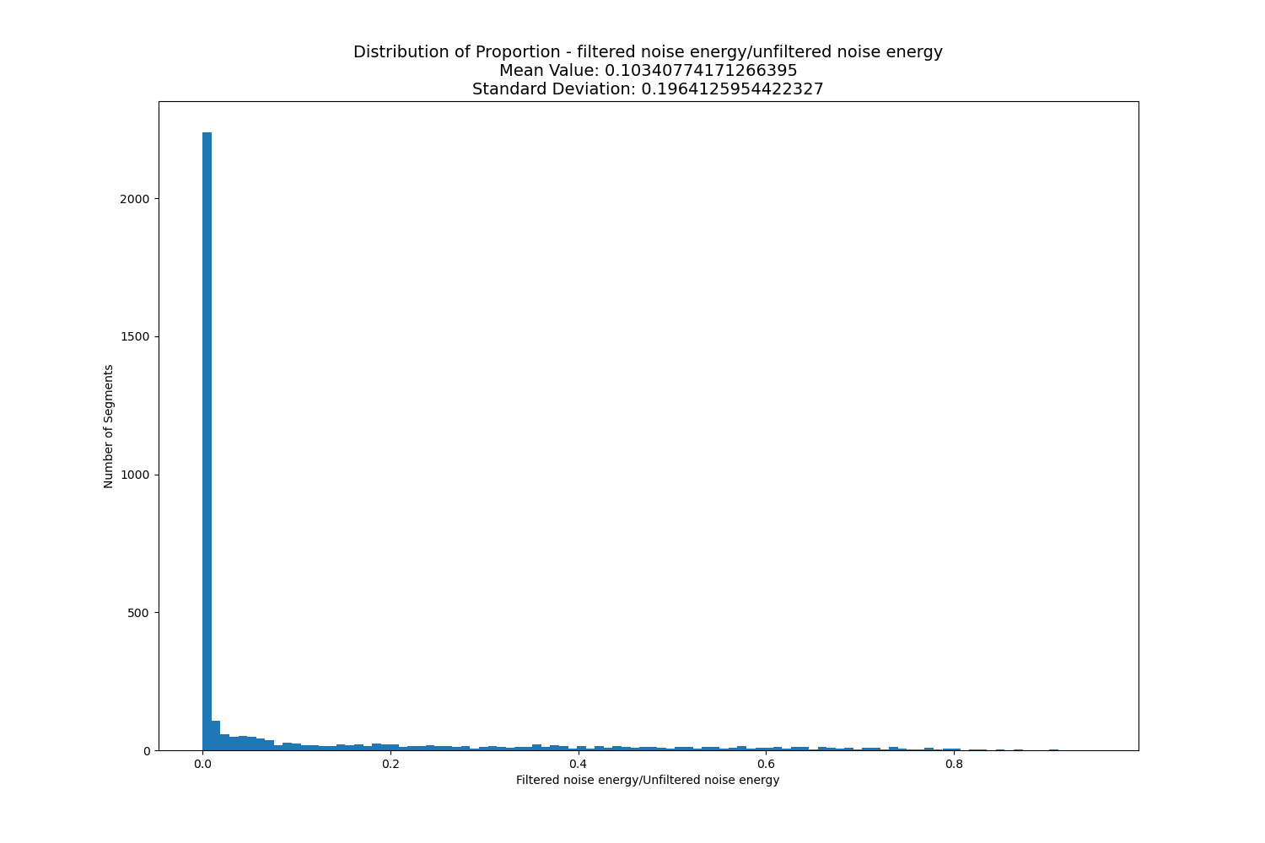

Figure - distribution of remaining noise energy after filtration among all noise segments. The mean value is 0.1034. The standard deviation is 0.19641

1. Conclusions:

This study demonstrates promising results for THA acoustic signal filtration using a spectral over-subtraction algorithm. The proposed pipeline architecture was able to separate hammer-on-broach hit sounds from background noise of the OR and filter out 89.659% of the noise while only losing 8.651% of signal energy. Furthermore, a novel spectral mapping of noise in ORs was carried out in the frequency range of 0-100 [kHz].

1. Future Goals:

The proposed method has the ability to emphasize the sounds of hammer-on-broach hits. In the ears of an experienced surgeon, the clean hits signals can make a vast difference in the selection of the optimal endpoint of insertion.

Furthermore, this method may contribute to the transition of endpoint selection from a subjective-based approach to an automated, frequency-based approach. These automated algorithms have the potential to be more accurate and reliable than a surgeon’s decision and may someday in the future be adapted as decision-aiding mechanisms in ORs.

1. Bibliography:

Abdulkarim, A., Elsibaei, A., Jackson, B., Riordan, D., & Rice, J. (2013). The use of sound analysis to guide femoral reaming in uncemented total hip arthroplasty: A new concept. *Orthopaedic Proceedings*, *95*(SUPP_34), 1–1.

Brien, W. W., Salvati, E. A., Betts, F., Bullough, P., Wright, T., Rimnac, C., Buly, R., & Garvin, K. (1992). Metal levels in cemented total hip arthroplasty. A comparison of well-fixed and loose implants. *Clinical Orthopaedics and Related Research*, *276*, 66–74.

Gheduzzi, S., & Miles, A. (2007). A review of pre-clinical testing of femoral stem subsidence and comparison with clinical data. *Proceedings of the Institution of Mechanical Engineers, Part H: Journal of Engineering in Medicine*, *221*(1), 39–46.

Goossens, Q., Pastrav, L., Roosen, J., Mulier, M., Desmet, W., Vander Sloten, J., & Denis, K. (2021). Acoustic analysis to monitor implant seating and early detect fractures in cementless THA: An in vivo study. *Journal of Orthopaedic Research®*, *39*(6), 1164–1173.

Jasty, M., Bragdon, C., Burke, D., O’CONNOR, D., Lowenstein, J., & Harris, W. H. (1997). In vivo skeletal responses to porous-surfaced implants subjected to small induced motions. *JBJS*, *79*(5), 707–714.

Kracht, J. M., Busch-Vishniac, I. J., & West, J. E. (2007). Noise in the operating rooms of Johns Hopkins Hospital. *The Journal of the Acoustical Society of America*, *121*(5), 2673–2680.

Lindahl, H. (2007). Epidemiology of periprosthetic femur fracture around a total hip arthroplasty. *Injury*, *38*(6), 651–654.

Lübbeke, A., Silman, A., Barea, C., Prieto-Alhambra, D., & Carr, A. (2018). Mapping existing hip and knee replacement registries in Europe. *Health Policy*, *122*(5), 548–557.

Morohashi, I., Iwase, H., Kanda, A., Sato, T., Homma, Y., Mogami, A., Obayashi, O., & Kaneko, K. (2017). Acoustic pattern evaluation during cementless hip arthroplasty surgery may be a new method for predicting complications. *SICOT-J*, *3*.

Oberst, S., Baetz, J., Campbell, G., Lampe, F., Lai, J. C., Hoffmann, N., & Morlock, M. (2018). Vibro-acoustic and nonlinear analysis of cadavric femoral bone impaction in cavity preparations. *International Journal of Mechanical Sciences*, *144*, 739–745.

Paech, A., Cabrera-Palacios, H., Schulz, A., Kiene, J., Wenzl, M., & Jurgens, C. (2008). Acoustic tests on hip prosthesis models using frequency resonance monitoring (FRM). *Res J Med Sci*, *2*(2), 82–91.

Partila, P., Voznak, M., Mikulec, M., & Zdralek, J. (2012). Fundamental frequency extraction method using central clipping and its importance for the classification of emotional state. *Advances in Electrical and Electronic Engineering*, *10*(4), 270–275.

Pumphrey, R. (1950). Upper limit of frequency for human hearing. *Nature*, *166*(4222), 571–571.

Sakai, R., Kikuchi, A., Morita, T., Takahira, N., Uchiyama, K., Yamamoto, T., Moriya, M., Uchida, K., Fukushima, K., Tanaka, K., & others. (2011). Hammering sound frequency analysis and prevention of intraoperative periprosthetic fractures during total hip arthroplasty. *Hip International*, *21*(6), 718–723.

Torun, Y., Öztürk, A., HatİpoĞlu, N., & Öztemür, Z. (2018). Breakthrough detection for orthopedic bone drilling via power spectral density estimation of acoustic emission. *2018 Electric Electronics, Computer Science, Biomedical Engineerings’ Meeting (EBBT)*, 1–5.

Tsiridis, E., Haddad, F. S., & Gie, G. A. (2003). The management of periprosthetic femoral fractures around hip replacements. *Injury*, *34*(2), 95–105.

Unger, A., Cabrera-Palacios, H., Schulz, A., Jürgens, C., & Paech, A. (2009). Acoustic monitoring (RFM) of total hip arthroplasty results of a cadaver study. *European Journal of Medical Research*, *14*(6), 264–271.

West, J., Busch-Vishniac, I., King, J., & Levit, N. (2008). Noise reduction in an operating room: A case study. *The Journal of the Acoustical Society of America*, *123*(5), 3677–3677.

Whitwell, G., Brockett, C. L., Young, S., Stone, M., & Stewart, T. D. (2013). Spectral analysis of the sound produced during femoral broaching and implant insertion in uncemented total hip arthroplasty. *Proceedings of the Institution of Mechanical Engineers, Part H: Journal of Engineering in Medicine*, *227*(2), 175–180.